**Installing Prerequisites**

**Summary:** In this document we are going to demonstrate how to properly install docker desktop with kubernetes integration on your machine

**Prerequisite:** Mac or Windows machine

**Log:**

| Change Made | Signature |
| --- | --- |
| Created Initial Doc | AG, SP |
|  |  |
|  |  |
|  |  |

Windows (10+)

1. Download and Install the Docker Desktop application from the Docker Documentation page: <https://docs.docker.com/desktop/install/windows-install/>

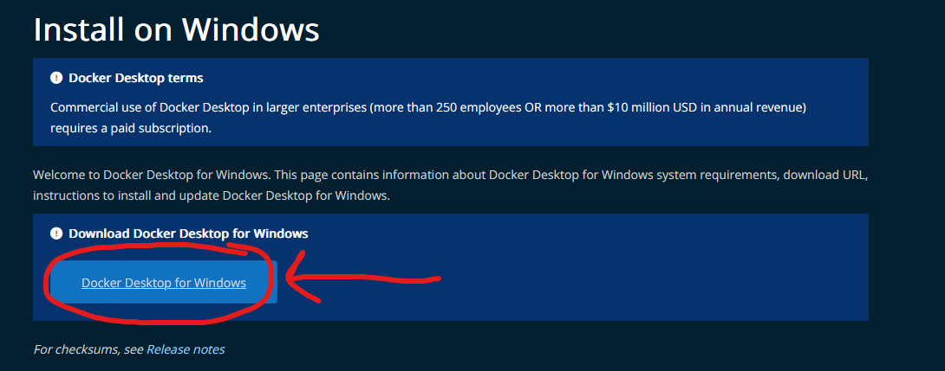

1. Follow the installation process until you are able to start Docker

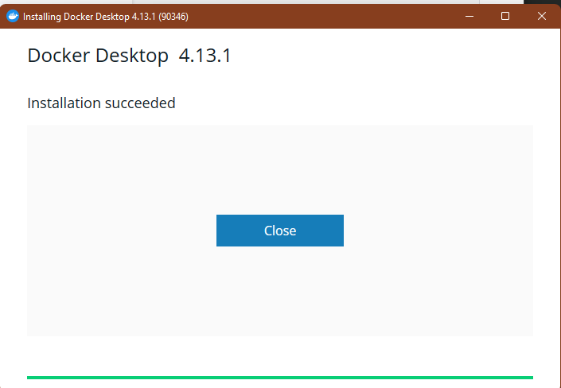

1. Open up Docker Desktop and let the process start up. Once the process opens, go ahead and open the settings tab on Docker

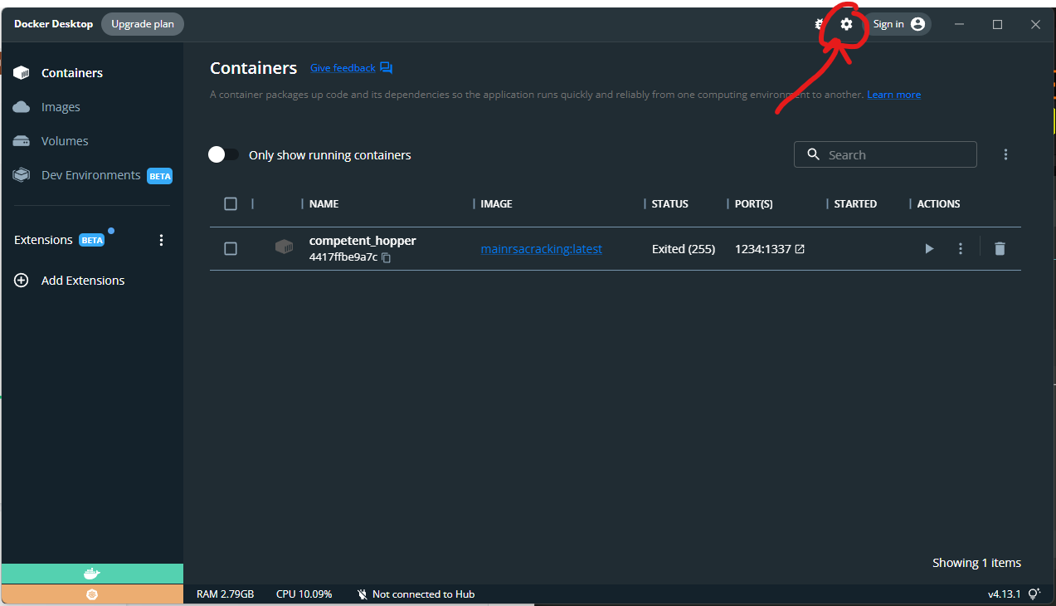

1. Within the Kubernetes tab on the left, select “Enable Kubernetes” and click Apply and Restart.

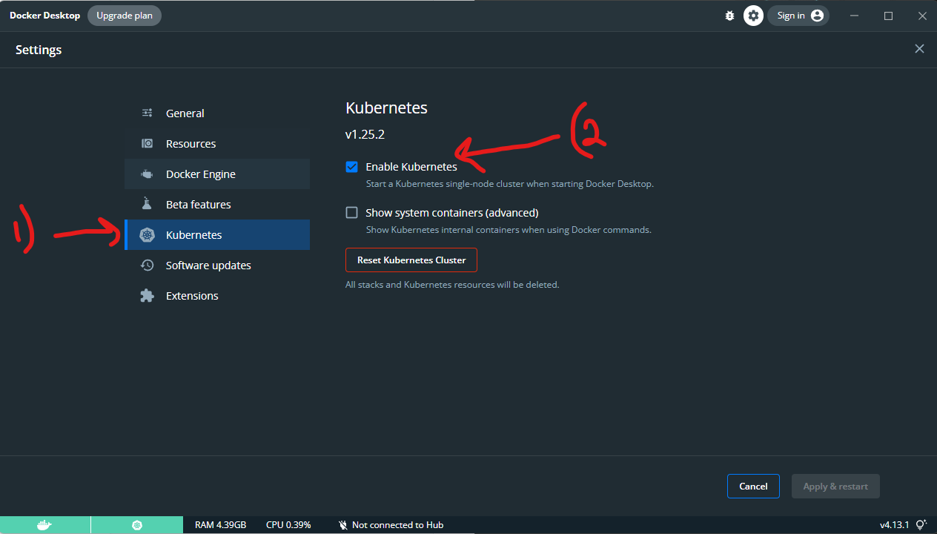

1. Once you apply and restart, wait for Docker to reboot and proceed to wait until you see the two services both green in the bottom left. This will conclude installing the pre-requisites.

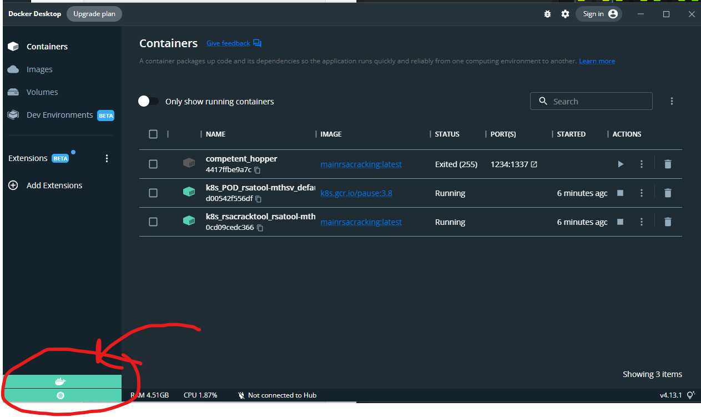

MacOS

1. Download and Install the Docker Desktop application from the Docker Documentation page:

<https://docs.docker.com/desktop/install/mac-install/>

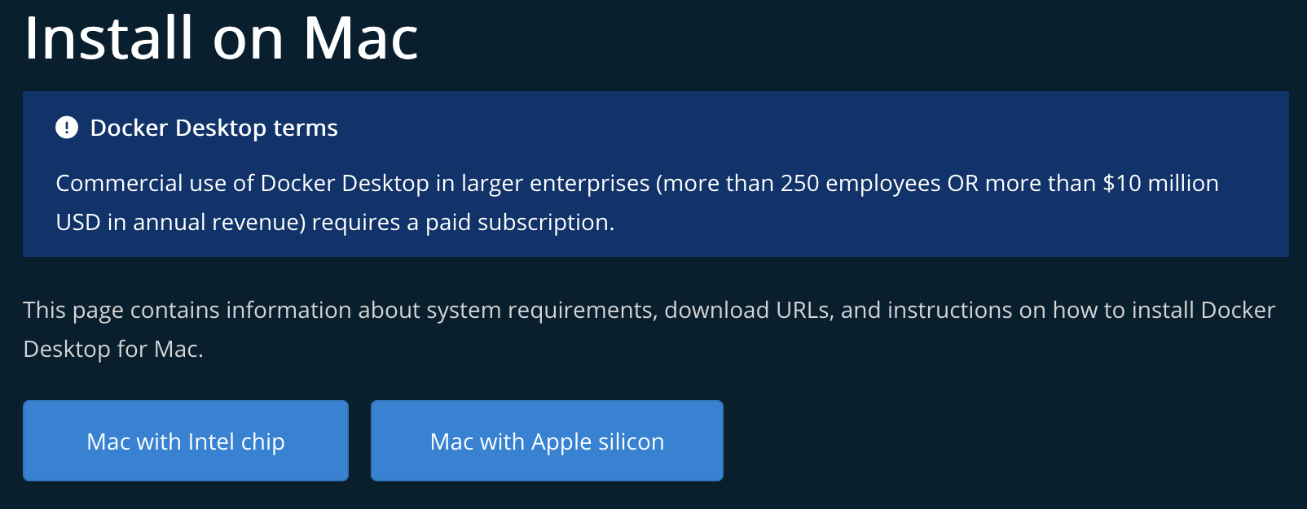

Select which version of Mac chip you have

1. Follow the installation process until you are able to start Docker
   1. When prompted do the following:
      1. Drag and drop Docker to applications
      2. Grant elevated permissions
2. Open up Docker Desktop and let the process start up. Once the process opens, go ahead and open the settings tab on Docker.



1. Within the Kubernetes tab on the left, select “Enable Kubernetes” and click Apply and Restart.



1. Once you apply and restart, wait for Docker to reboot and proceed to wait until you see the two services both green in the bottom left. This will conclude installing the pre-requisites.

